PROJECT DOCUMENTATION

Project Title- Airline Crew Scheduling UI

Student Name(s) | MONDU SRI SAI MURALI VEER SAMPATH (2520090005)  P JAHNAVI (2520090012)
Section / Branch | SECTION – 7 (CSIT)
Academic Year | I – III SEM
Course | ( 25CS1201E)
Course Code | Front End Development Framework and UI Engineering
Faculty Guide | - Shiva Krishna Assistant Professor ]
Date of Submission | [ DD Month YYYY ]

Table of Contents
(Update in MS Word: Right-click → Update Field → Update entire table)
Abstract
Chapter 1: Introduction
- 1.1 Problem Statement
- 1.2 Objectives
- 1.3 Scope
Chapter 2: Requirements
- 2.1 Functional & Non-Functional Requirements
- 2.2 Use Case Summary
Chapter 3: System Design
- 3.1 System Architecture
- 3.2 Component Hierarchy
- 3.3 Route Map
- 3.4 UI Wireframes
Chapter 4: Implementation
- 4.1 Technology Stack
- 4.2 Key Modules
  - 4.2.1 Routing Module
  - 4.2.2 Form Engineering
  - 4.2.3 Accessibility
  - 4.2.4 Performance Optimizations
- 4.3 Challenges and Solutions
Chapter 5: Testing
- 5.1 Test Cases
Chapter 6: Results and Discussion
- 6.1 Screenshots
- 6.2 Discussion
Chapter 7: Conclusion and Future Work
- 7.1 Conclusion
- 7.2 Lessons Learned
- 7.3 Future Enhancements
Appendix
- A. GitHub Repository
- B. Installation
- C. Individual Contribution

Abstract

The Airline Crew Scheduling System is a web-based application developed to simplify airline crew management and flight scheduling. It enables administrators to manage crew details, assign personnel to flights, monitor leave requests, and detect scheduling conflicts efficiently. The system provides an interactive dashboard for viewing rosters and includes AI-assisted schedule optimization to improve planning and resource utilization. Developed using React, TypeScript, and Vite with a modern user interface, the application enhances operational efficiency while reducing manual scheduling errors. The project demonstrates responsive design, component-based architecture, and real-time data handling, resulting in a reliable and user-friendly scheduling platform.

Keywords: React, TypeScript, Airline Crew Scheduling, Flight Management, AI Scheduling, Vite

Chapter 1: Introduction

1.1 Problem Statement
Airlines often face challenges in manually assigning crew members to flights while considering availability, leave requests, and scheduling conflicts. Manual processes are time-consuming and prone to errors. This project addresses these issues by providing a centralized web application that automates crew scheduling, improves resource management, and assists administrators with intelligent scheduling suggestions.

1.2 Objectives
- To design and implement a responsive Airline Crew Scheduling System using React.
- To manage crew member information efficiently.
- To schedule flights and assign suitable crew members.
- To process and monitor crew leave requests.
- To detect scheduling conflicts automatically.
- To provide AI-powered scheduling assistance for better planning.

1.3 Scope
The project focuses on airline crew management, flight scheduling, roster visualization, leave management, and AI-assisted scheduling recommendations. It provides an intuitive front-end interface with efficient data handling. Advanced airline operations such as ticket booking, payment processing, and airport logistics are outside the scope of this project.

Chapter 2: Requirements

2.1 Functional & Non-Functional Requirements
The table below lists the key requirements of the system:

ID | Type | Requirement | Priority | Category
R-01 | Functional | Users can securely log in and access the system dashboard. | High | Authentication
R-02 | Functional | Administrators can add, edit, delete, and manage crew member details. | High | Crew Management
R-03 | Functional | The system allows scheduling and assigning crew members to flights. | High | Flight Scheduling
R-04 | Functional | Crew members can submit leave requests and administrators can approve or reject them. | High | Leave Management
R-05 | Functional | The system automatically detects scheduling conflicts before assigning crew. | High | Conflict Detection
R-06 | Functional | AI-powered scheduling assistant provides optimized crew assignment suggestions. | Medium | AI Scheduling
R-07 | Functional | Dashboard displays crew rosters, flight schedules, and operational summaries. | Medium | Dashboard
R-08 | Non-Functional | The application should load within 3 seconds under normal network conditions. | High | Performance
R-09 | Non-Functional | The user interface should be responsive across desktop, tablet, and mobile devices. | High | Usability
R-10 | Non-Functional | The system should ensure data security and reliable access for authorized users only. | High | Security

2.2 Use Case Summary
Use Case | Actor | Precondition | Main Flow | Outcome
Manage Crew Members | Administrator | Admin is logged in | Add, update, or remove crew member details from the system. | Crew information is stored and updated successfully.
Schedule Flight Crew | Administrator | Crew and flight records exist | Assign available crew members to flights and verify scheduling conflicts. | Flight schedule is created with valid crew assignments.
Manage Leave Requests | Crew Member / Administrator | User is authenticated | Crew submits leave request; admin reviews and approves or rejects it. | Leave status is updated and reflected in crew availability.
Chapter 3: System Design

3.1 System Architecture
The system follows a client-server architecture where users interact with a React-based frontend. Requests are processed through application logic that manages crew records, flight schedules, leave requests, and AI-based optimization features. The architecture ensures modularity, responsiveness, and scalability.
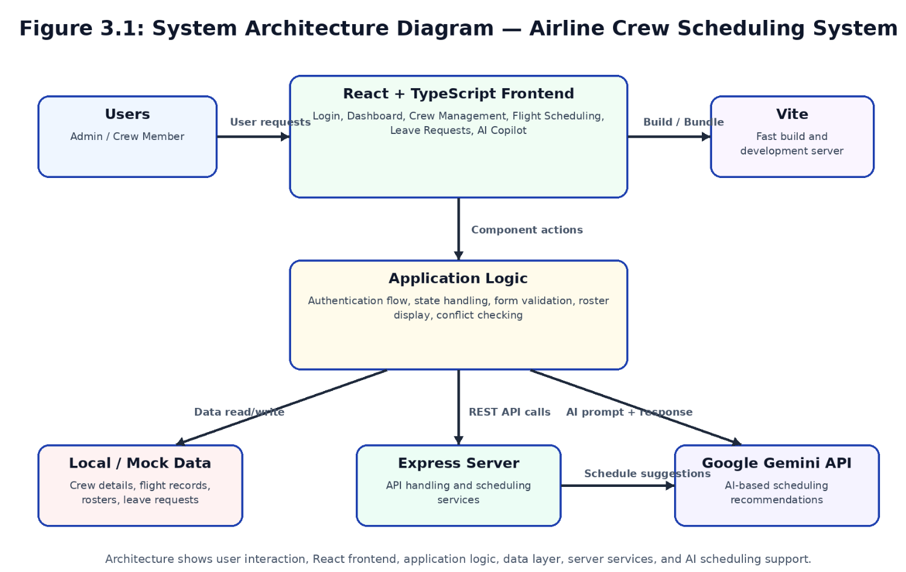
Figure 3.1: System Architecture Diagram

3.2 Component Hierarchy

Component | Responsibility
App.tsx | Main application controller and navigation
Login.tsx | User authentication
RosterDashboard.tsx | Displays crew schedules and dashboards
CrewManagement.tsx | Manages crew information
FlightScheduling.tsx | Creates and manages flight schedules
LeaveRequests.tsx | Handles leave applications
AICopilot.tsx | Provides AI-assisted scheduling recommendations

3.3 Route Map

Path | Component | Access
/ | Login | Public
/dashboard | RosterDashboard | Authenticated
/crew | CrewManagement | Authenticated
/flights | FlightScheduling | Authenticated
/leave | LeaveRequests | Authenticated
/ai | AICopilot | Authenticated

3.4 UI Wireframes
[ Insert wireframe images of your key screens. Add a figure caption for each. Minimum: Home page, a form page, and the dashboard. ]

[ Insert Wireframe — Home Page ]
Figure 3.2: Wireframe — Home Page

Chapter 4: Implementation

4.1 Technology Stack

Category | Technology | Purpose
UI Library | React | Front-end development
Language | TypeScript | Type-safe programming
Build Tool | Vite | Fast development and bundling
Styling | CSS | User interface styling
State Management | React Hooks | Local state management
Backend | Express.js | Server-side processing
AI Integration | Google Gemini API | Schedule optimization
Version Control | Git & GitHub | Source code management

4.2 Key Modules

4.2.1 Routing Module
The application manages navigation between the login page, dashboard, crew management, flight scheduling, leave requests, and AI scheduling assistant through a centralized routing structure.

4.2.2 Form Engineering
Forms are implemented for crew registration, flight scheduling, and leave requests with input validation to ensure accurate and complete data entry.

4.2.3 Accessibility
- Responsive user interface.
- Clear navigation menus.
- Readable typography and layouts.
- Consistent form labels and controls.
- User-friendly dashboard design.

4.2.4 Performance Optimizations
- Efficient React component rendering.
- Reusable components to reduce duplication.
- Optimized state management with React Hooks.
- Fast builds using Vite.
- Modular architecture for better maintainability.

4.3 Challenges and Solutions

Challenge | Solution Adopted
Avoiding overlapping crew schedules | Implemented conflict detection before assignment
Managing multiple flight records | Used modular components and centralized state
Handling leave requests with scheduling | Updated roster dynamically after leave approval
Improving scheduling efficiency | Integrated AI-assisted optimization

Chapter 5: Testing

5.1 Test Cases

TC ID | Module | Test Description | Expected Result | Status
TC-01 | Login | Login with valid credentials | User is successfully redirected to the dashboard | Pass ✅
TC-02 | Login | Login with invalid credentials | Error message is displayed and access is denied | Pass ✅
TC-03 | Crew Management | Add a new crew member | Crew member is added and displayed in the crew list | Pass ✅
TC-04 | Flight Scheduling | Assign crew to a scheduled flight | Crew is assigned successfully without conflicts | Pass ✅
TC-05 | Leave Management | Submit a leave request | Leave request is recorded and shown in the leave list | Pass ✅
TC-06 | Conflict Detection | Assign a crew member to overlapping flights | System detects the conflict and prevents assignment | Pass ✅
TC-07 | AI Scheduling | Generate AI-based crew schedule suggestions | Optimized scheduling recommendations are displayed | Pass ✅
TC-08 | Dashboard | View roster and flight schedule | Dashboard loads correctly and displays updated information | Pass ✅

Chapter 6: Results and Discussion

6.1 Screenshots
[ Insert screenshots of your working application. Add a figure number and caption for each. Minimum: Home page, form with validation errors, and the protected page. ]

[ Insert Screenshot — Home Page ]
Figure 6.1: Home Page — Desktop View

[ Insert Screenshot — Form with Validation Errors ]
Figure 6.2: Registration Form — Validation Error Surfaces

6.2 Discussion

The developed Airline Crew Scheduling System successfully streamlined crew management and scheduling tasks through an intuitive interface and modular architecture. Features such as roster visualization, leave management, and conflict detection reduced manual effort and improved scheduling accuracy. The AI-assisted scheduling component further enhanced decision-making by suggesting optimized crew assignments.

Although the system performs efficiently for demonstration and academic purposes, future improvements can include real-time database synchronization, role-based permissions, and integration with external airline management systems for enterprise deployment.

Chapter 7: Conclusion and Future Work
7.1 Conclusion
The project successfully achieved its objectives by providing a modern Airline Crew Scheduling System capable of managing crew information, scheduling flights, handling leave requests, and detecting conflicts. The integration of AI-assisted scheduling improved operational planning and demonstrated the effectiveness of intelligent automation in airline management.
7.2 Lessons Learned
- React components improve code reusability.
- TypeScript enhances code reliability.
- Modular design simplifies maintenance.
- AI integration can improve scheduling efficiency.
7.3 Future Enhancements
- Integrate a real-time cloud database.
- Implement role-based access control.
- Add mobile application support.
- Include predictive analytics for crew availability.

Appendix

A. GitHub Repository
Project Repository URL:
https://github.com/[ username ]/[ repository-name ]
Branch: main | Commit history includes descriptive commit messages per feature.

B. Installation
- Clone: git clone https://github.com/[ username ]/[ repo ].git
- Navigate: cd [ repo-name ]
- Install dependencies: npm install
- Start dev server: npm run dev
- Open in browser: http://localhost:5173

C. Individual Contribution (Group Projects)

Student Name | Roll Number | Modules / Contributions
[ Name 1 ] | [ Roll No ] | [ e.g., Routing, Protected Routes, Navbar ]
[ Name 2 ] | [ Roll No ] | [ e.g., Form Engineering, Validation Hook ]
[ Name 3 ] | [ Roll No ] | [ e.g., Accessibility, Performance Tuning ]
[ Name 4 ] | [ Roll No ] | [ e.g., Testing, Documentation ]

